CLDV6211 poe part 2

ST10356506

URL: <https://st10356506.azurewebsites.net>

KhumaloCraft ERD

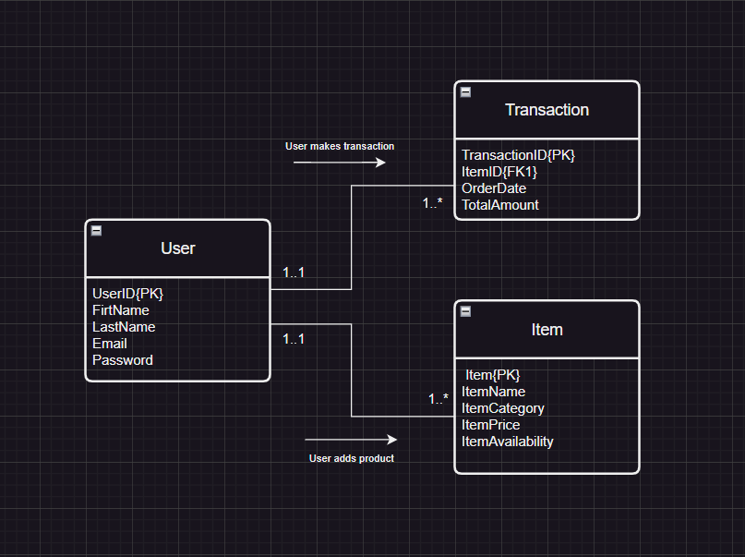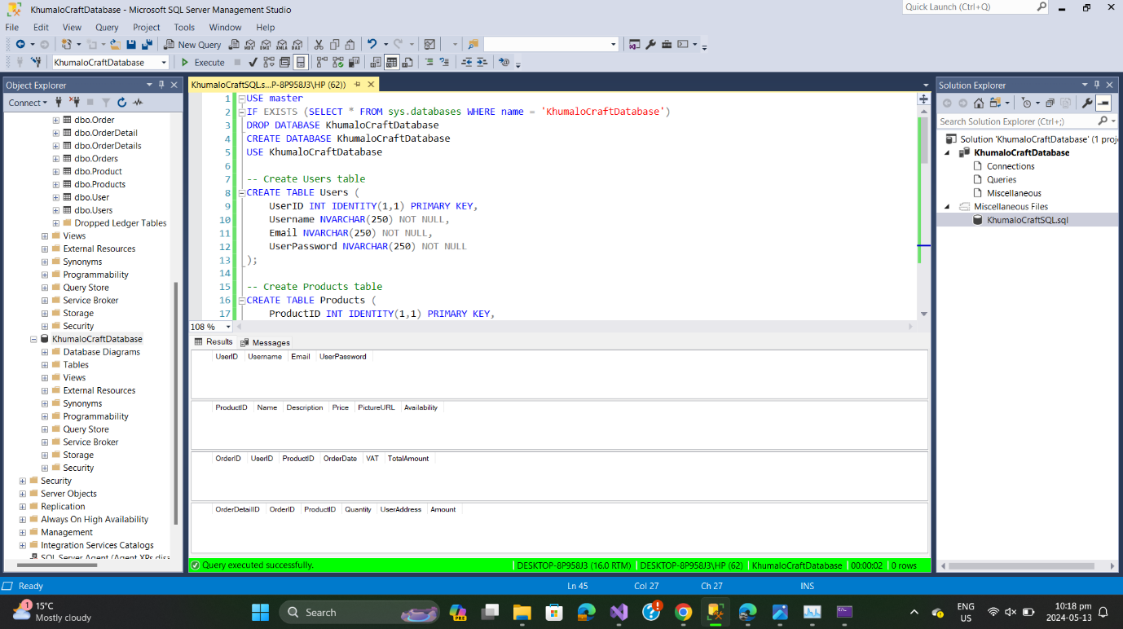

Deploying the database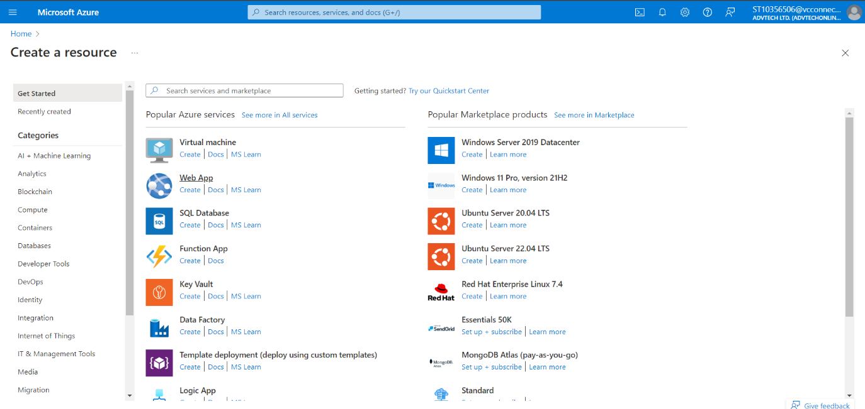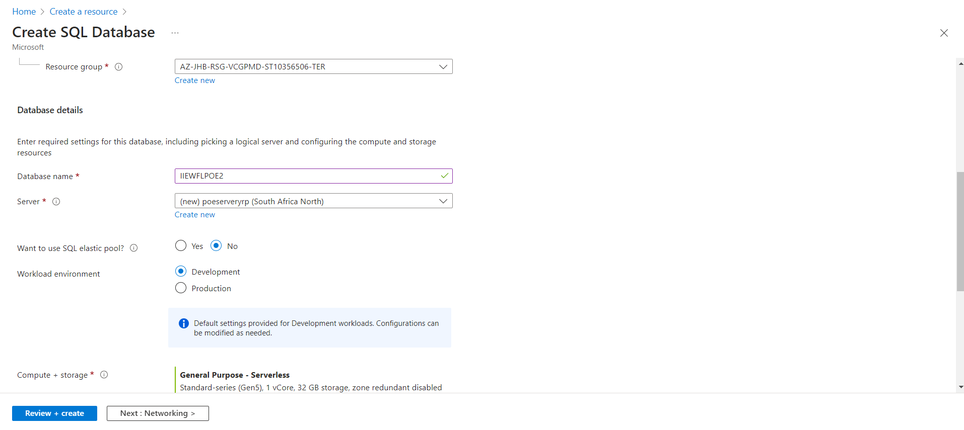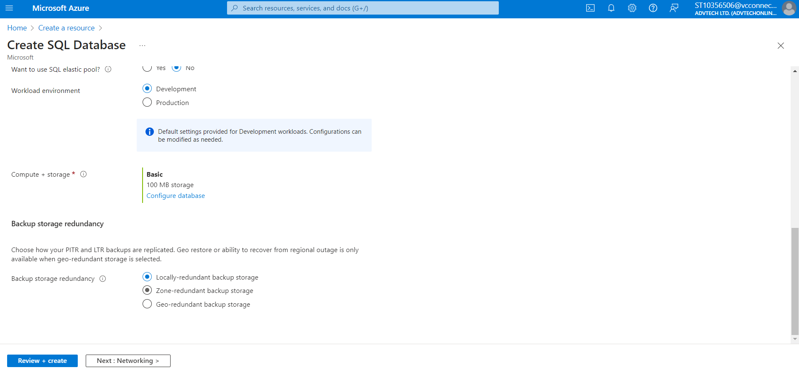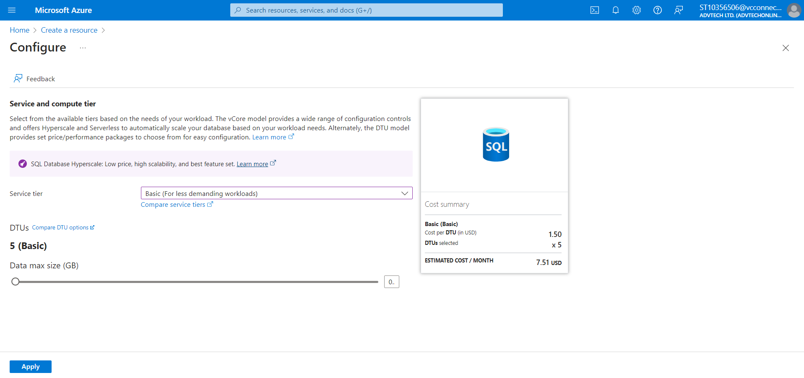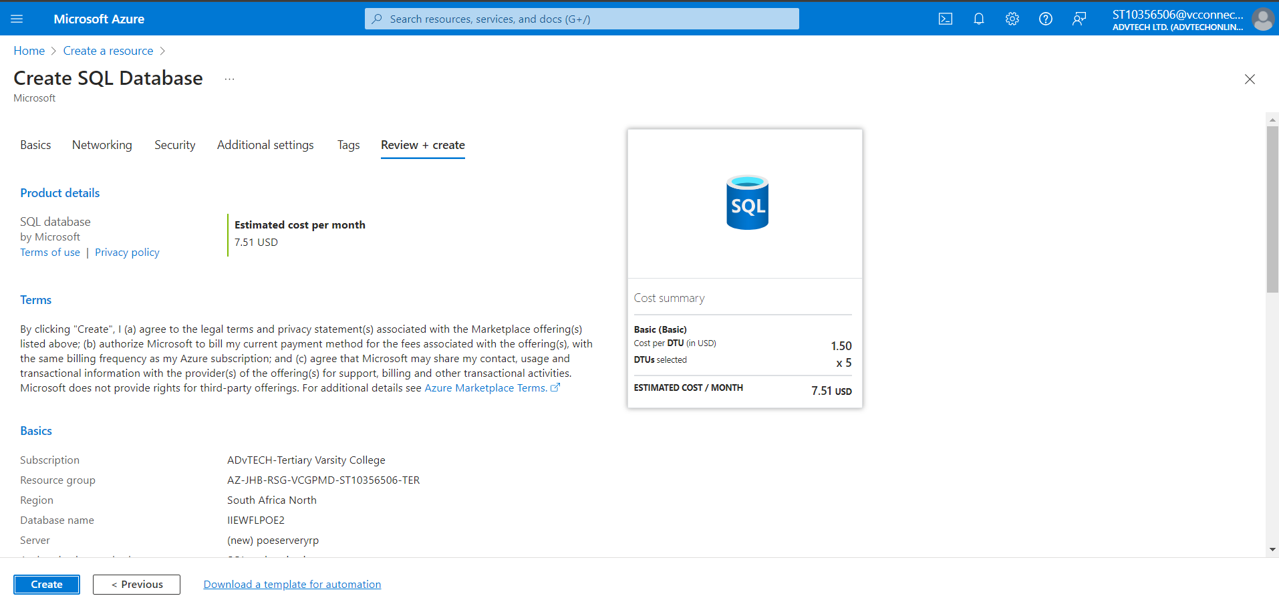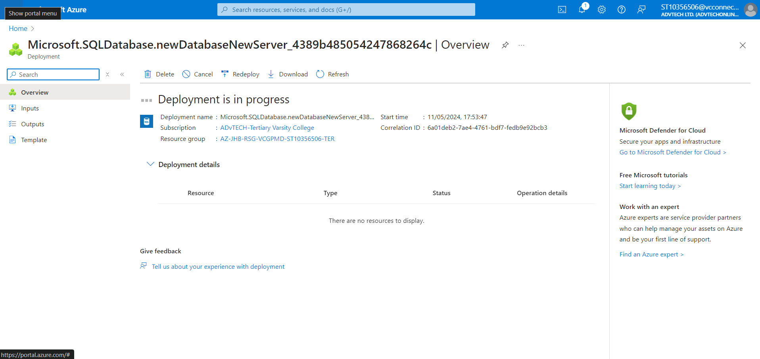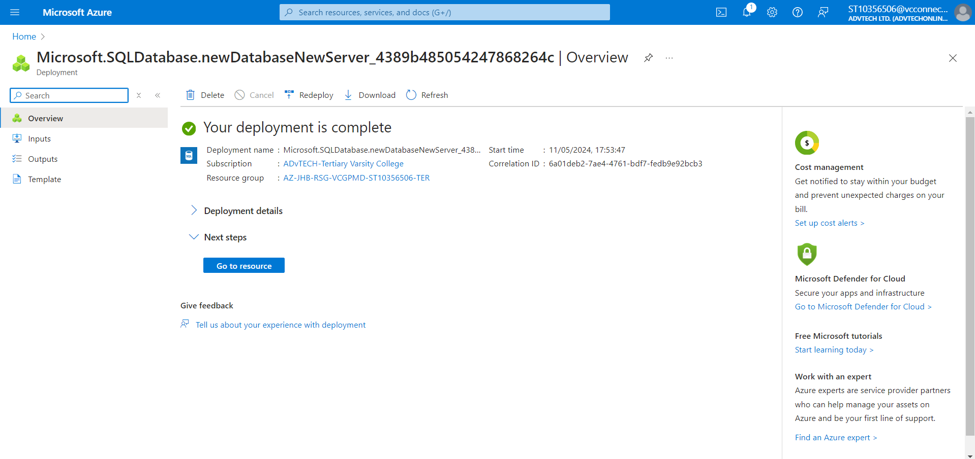

* 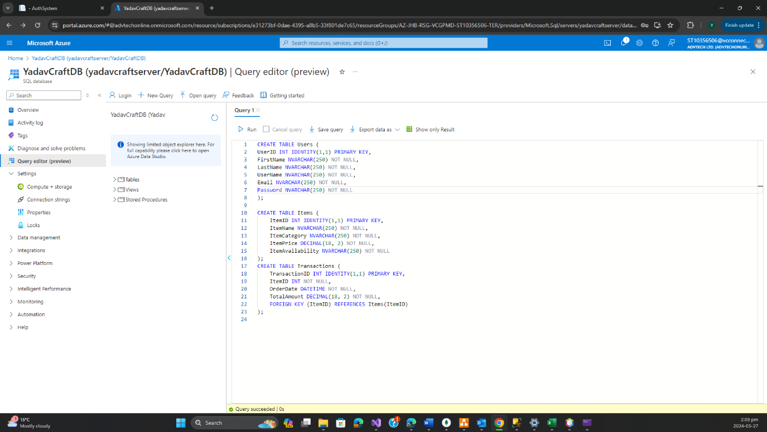

Web application (My Work Page)

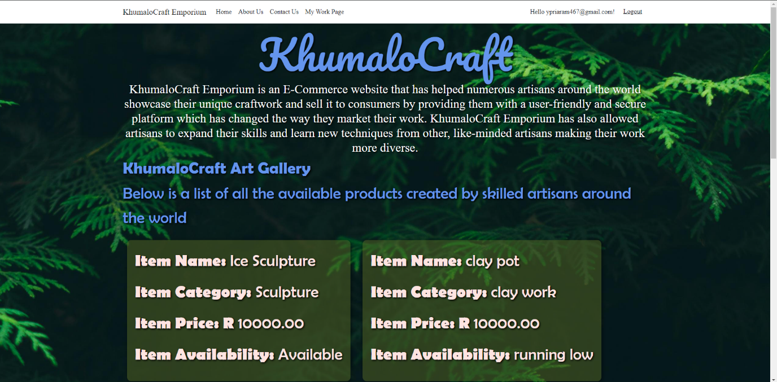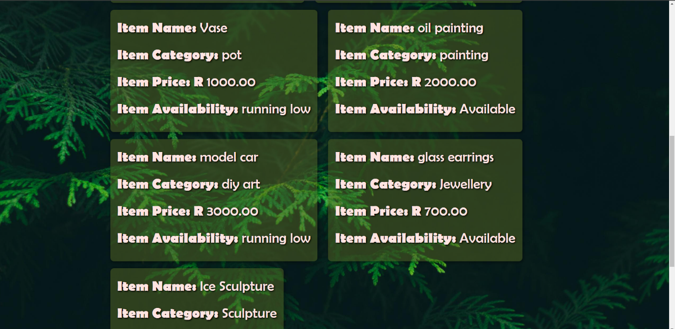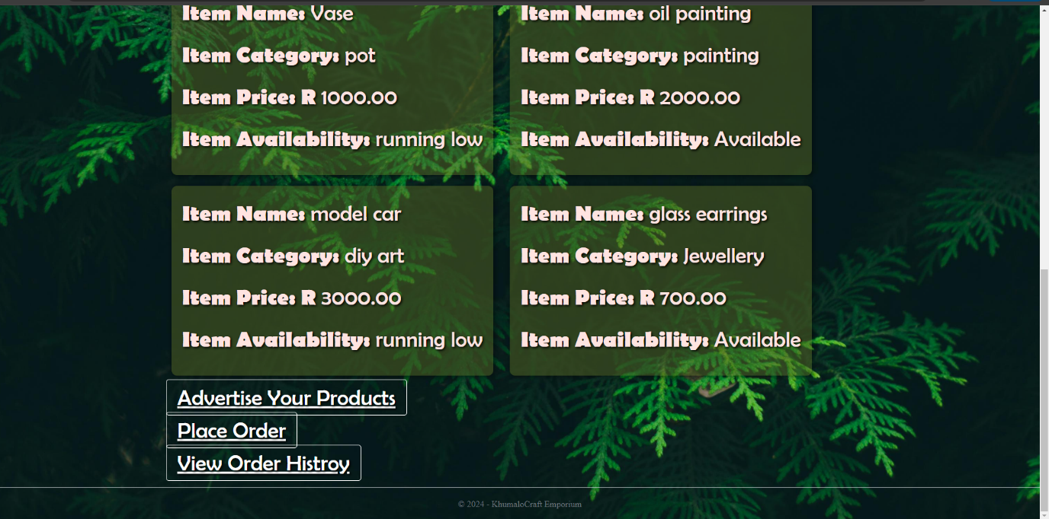

Screenshots of the user entering data to the database

Creating new user

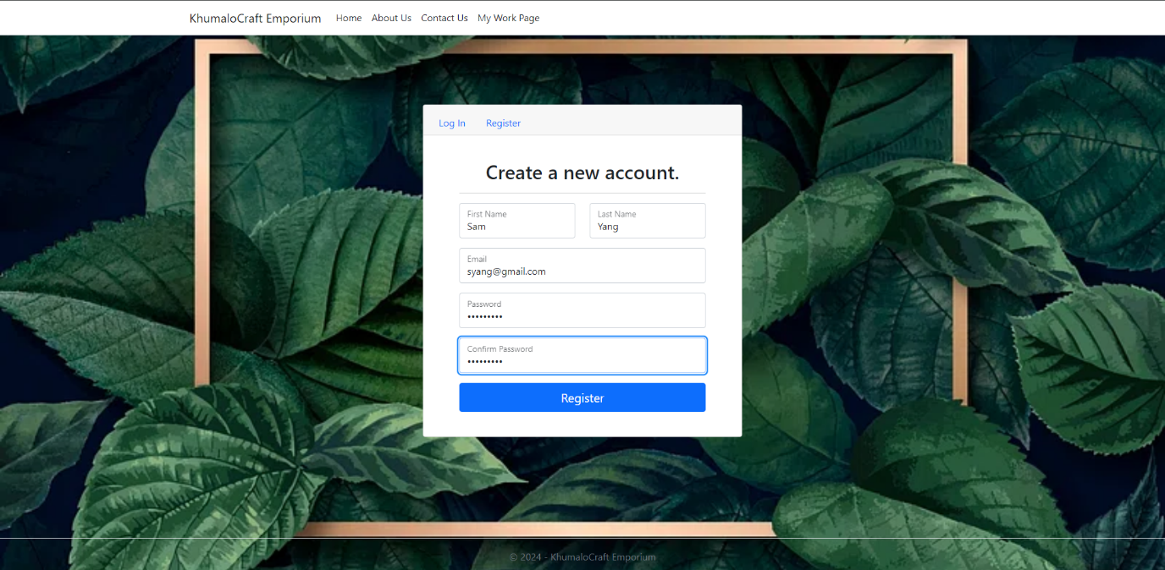

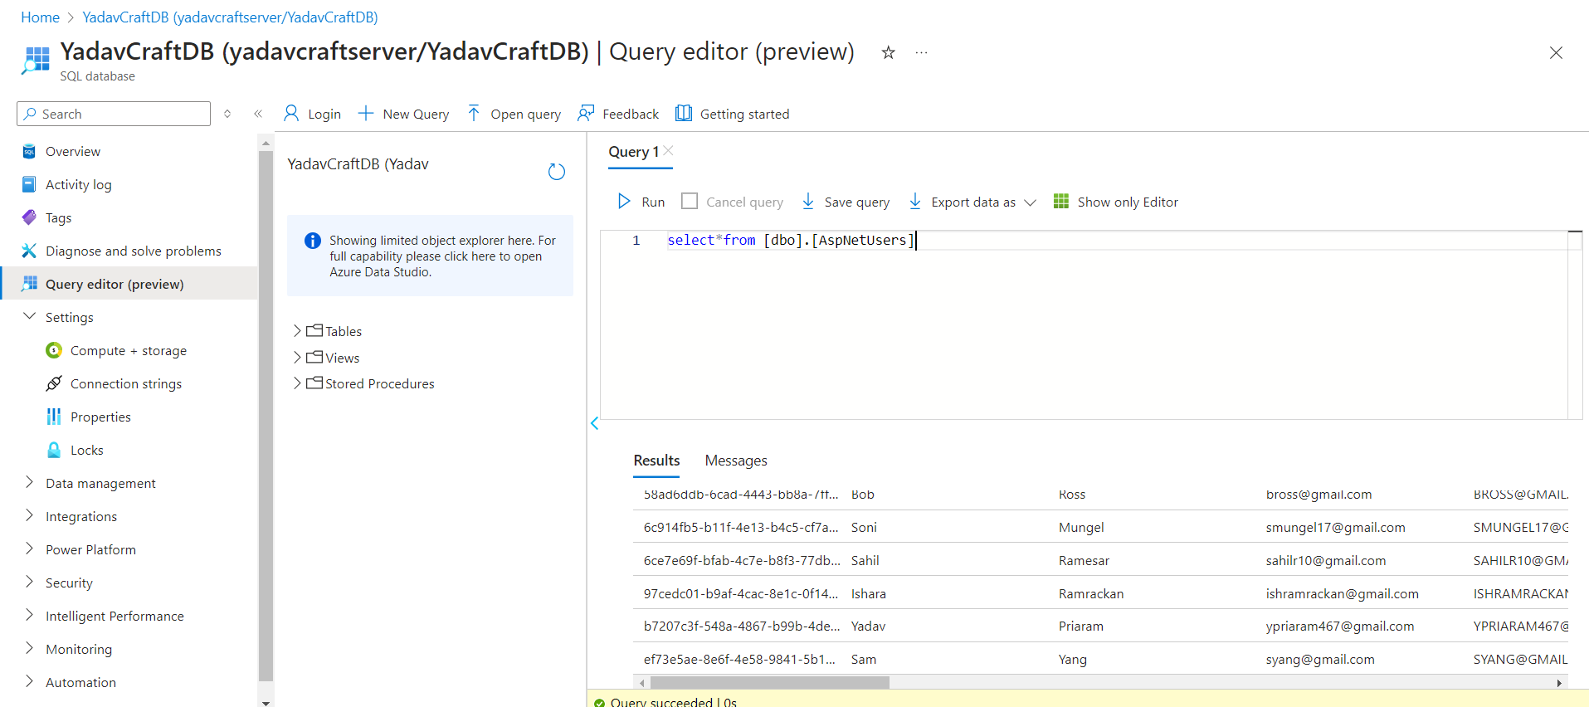

Uploading product

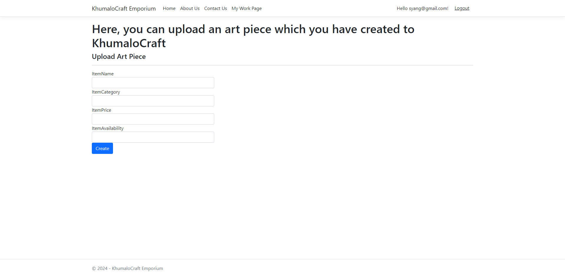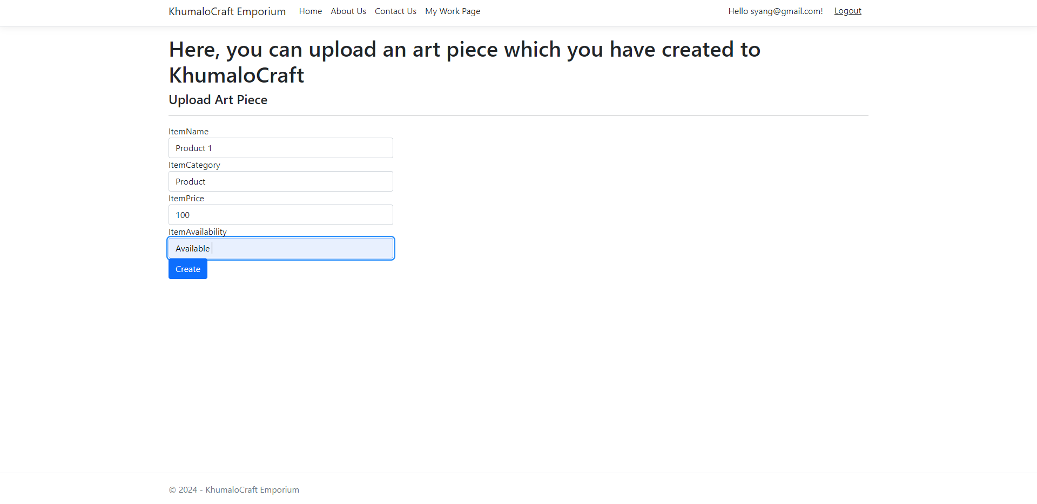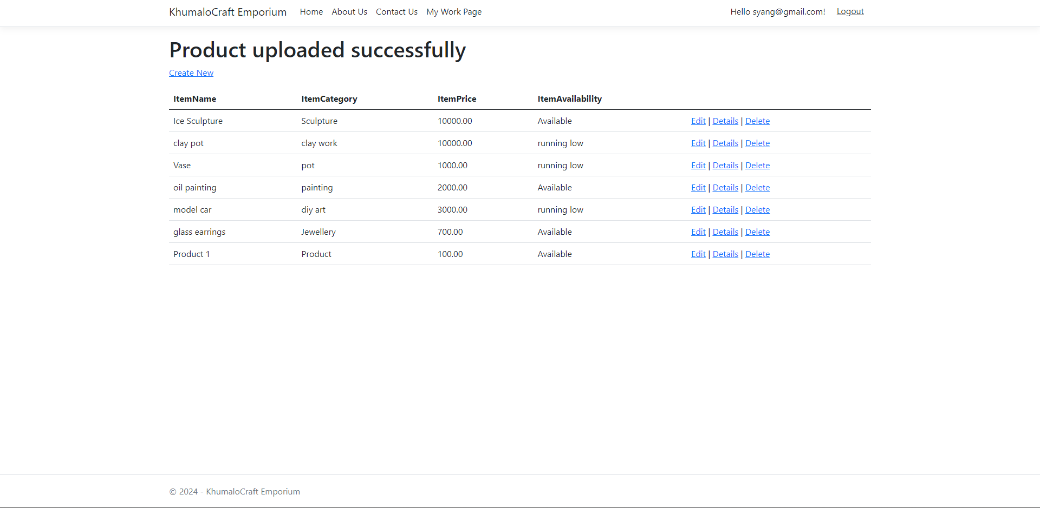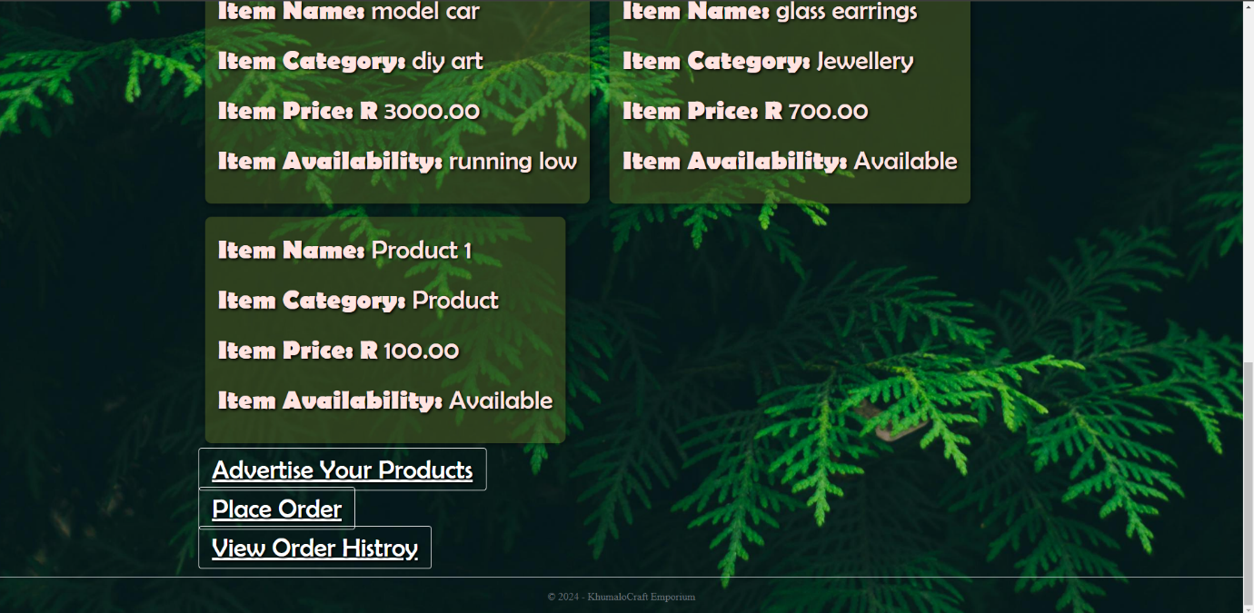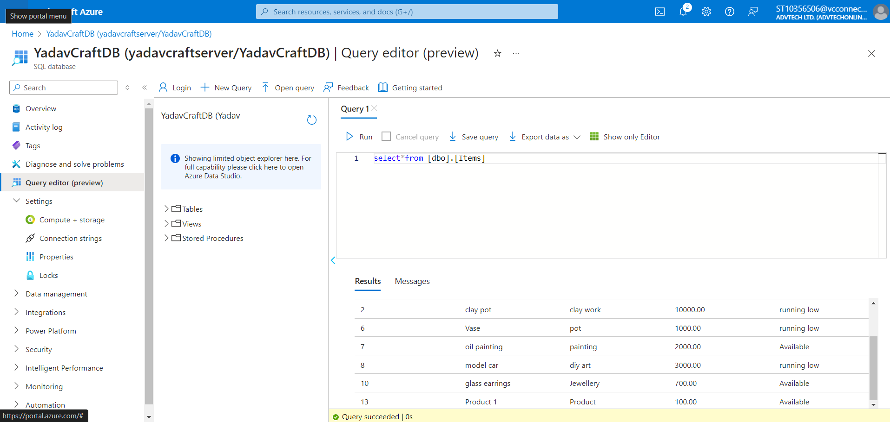

Placing an Order

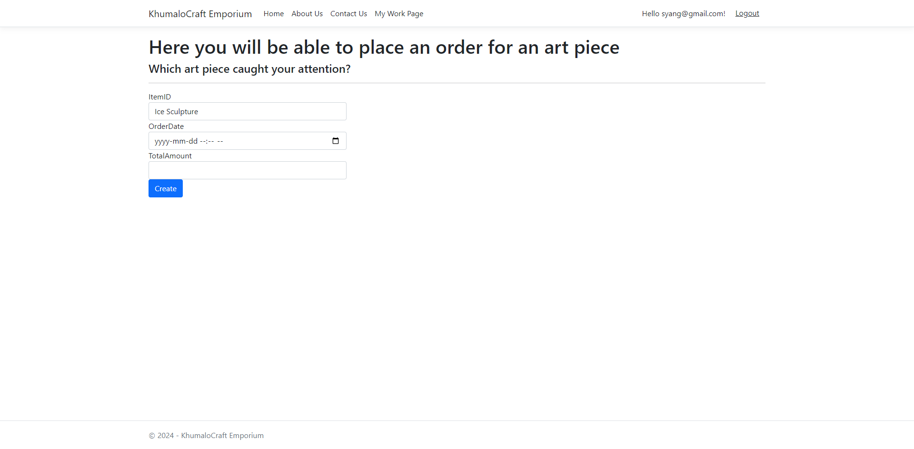

Viewing order history

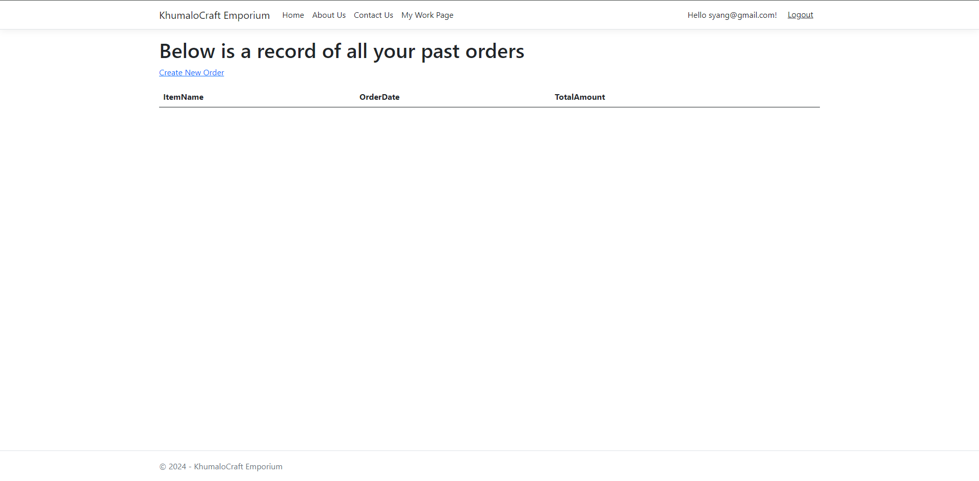

Referencing

(No date a) *CSS Buttons*. Available at: <https://www.w3schools.com/css/css3_buttons.asp> (Accessed: 27 May 2024).

(No date b) *HTML dom button object*. Available at: <https://www.w3schools.com/jsref/dom_obj_pushbutton.asp> (Accessed: 27 May 2024).

*ASP.NET razor - C# logic conditions* (no date) *ASP.NET Razor C# Logic*. Available at: <https://www.w3schools.com/asp/razor_cs_logic.asp> (Accessed: 27 May 2024).

*ASP.NET web pages - tutorial* (no date) *ASP.NET Web Pages Tutorial*. Available at: <https://www.w3schools.com/asp/webpages_intro.asp> (Accessed: 27 May 2024).

CodAffection (2023) *ASP.NET core MVC & Identity Ui - user registration and Login*, *YouTube*. Available at: <https://www.youtube.com/watch?v=wzaoQiS_9dI&t=175s> (Accessed: 27 May 2024).

Code, M. (2022) *Create ASP.NET CORE web application with SQL Server Database Connection and CRUD operations*, *YouTube*. Available at: <https://www.youtube.com/watch?v=rTM6Q000cLw&t=1362s> (Accessed: 27 May 2024).

Fix (2023) *Fix: System.nullreferenceexception : Object reference not set to instance of an object ASP.NET Core*, *YouTube*. Available at: <https://www.youtube.com/watch?v=lkpjS73lwCw> (Accessed: 27 May 2024).

Grievous, G. (2016) *ASP.NET C# - SQL server - display data from a DB on a web page part 2 of 2*, *YouTube*. Available at: <https://www.youtube.com/watch?v=6ZbiIL5CvGw&t=28s> (Accessed: 27 May 2024).

Gudmestad, E. (2023) *ASP.NET core MVC - how to have multiple pages that solve different problems*, *YouTube*. Available at: <https://www.youtube.com/watch?v=XjH1b0FBAeo&t=60s> (Accessed: 27 May 2024).

Mark Otto, J.T. (no date) *Navs and tabs*, *· Bootstrap v5.0*. Available at: <https://getbootstrap.com/docs/5.0/components/navs-tabs/> (Accessed: 27 May 2024).

RyeNyeTheComputerScienceGuyRyeNyeTheComputerScienceGuy                      17244 silver badges2121 bronze badges, Chris PrattChris Pratt                      237k3737 gold badges396396 silver badges454454 bronze badges and MichaelMichael                      5066 bronze badges (1960) *How to write a dbcontext class.*, *Stack Overflow*. Available at: <https://stackoverflow.com/questions/26425686/how-to-write-a-dbcontext-class> (Accessed: 27 May 2024).